**Lab** **1** **-** **Introduction** **to** **Windows** **Server**

**2016**

**Requirements**:

- **You** **need** **to** **complete** **all** **questions** **for** **each** **activity,** **and** **organise** **your** **answers** **into** **a** **word** **document.**

- **Although** **you** **are** **not** **required** **to** **submit** **your** **answers** **to** **VU** **Collaborate,** **these** **answers** **may** **be** **required** **to** **provide** **in** **the** **Mid-Semester** **and** **Final** **Examination.**

Activity 1- 1: Determining the Windows Server 2016 Edition

**Objective**: Determine the Windows Server 2016 edition installed on a computer.

**Description**: A computer room might have only a few or hundreds of servers. Sometimes it is important for a server administrator to verify which edition of Windows Server 2016 is running on a particular server. In this activity, you learn how to make a quick determination. You will need a server account provided by your instructor or server administrator.

1. Sign in to Windows Server 2016 using your account.

2. If Server Manager is not already open, click Start and click the Server Manager tile (or click Start and click Server Manager under S in the listing of selections).

3. Click Local Server in the left pane of Server Manager.

4. Locate Operating system version under Properties in the right pane. Here you’ll see the edition of Windows Server 2016, such as Microsoft Windows Server 2016 Datacenter or Microsoft Windows

Server 2016 Datacenter Evaluation (if you are using an evaluation version).

. *Which* *version* *of* *Windows* *Server* *2016* *is* *installed* *onyour* *computer?*

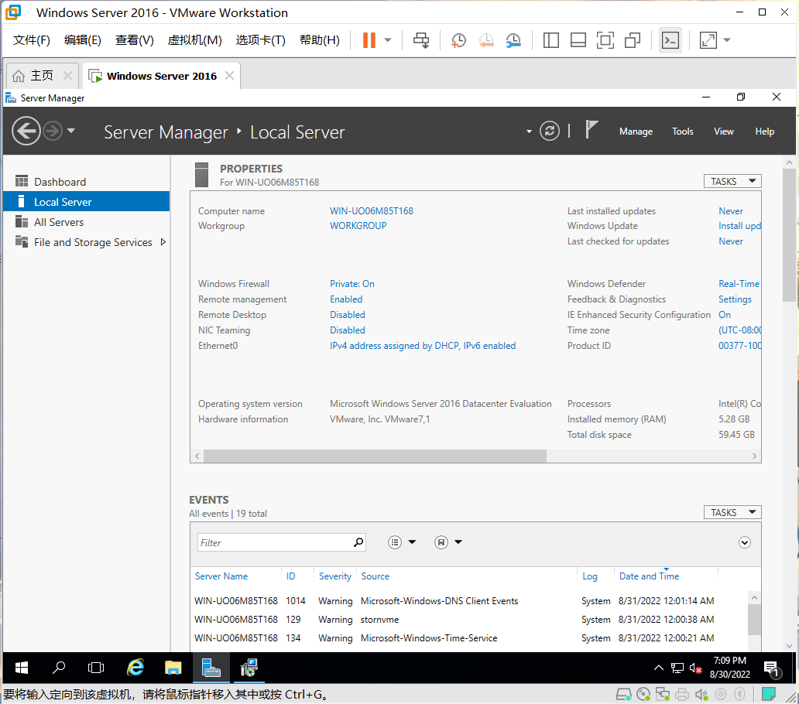

5. Notice the other information available in this window.

*•* *Is* *the* *Windows* *Firewall* *turned* *on?*

Yes

Activity 1-2: Viewing Running Processes

**Objective**: View the processes running in Windows Server 2016 using Resource Monitor. **Description**: Windows Server 2016 runs many processes at any one time. Some of the processes are used by a program you are using, such as Windows Explorer. Other processes are running in the background, such as a process for your desktop background. In this activity, you view the running processes using a tool in Windows Server 2016 called Resource Monitor.

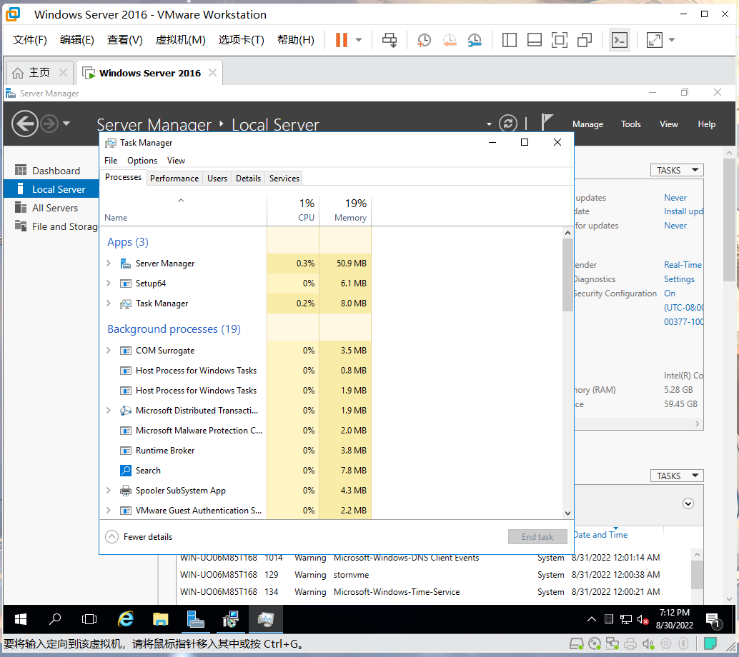

1. Ensure your computer is signed in and make certain that Server Manager is already running. If Server Manager is not open, click Start and click the Server Manager tile; or click Start and click Server Manager under the S in the listing.

2. Click Local Server in the left pane of Server Manager.

3. In the menu bar at the top of the Server Manager window, click Tools to see a drop-down menu of administrative tools.

4. Click Resource Monitor.

5. Ensure that the Overview tab is selected.

6. Move the cursor so that it is on top of the line just above the Disk section in Resource Monitor and you see an up and down arrow. With the up and down arrow displayed, drag the Disk section down to view more of the processes shown in the CPU section.

7. Scroll through the CPU section and notice that ServerManager.exe is one of the running processes.

8. Using the scroll bar, examine all of the processes that are running.

*•* *Record* *the* *names* *of* *two* *processes* *other* *than* *ServerManager.exe.*

Task Manager

Server Manager

9. Close Resource Monitor, but leave Server Manager open.

Activity 1-3: Determining if a Computer Is in a Domain or a Workgroup

**Objective**: Discover if a particular computer is in a domain or a workgroup.

**Description**: Some networks combine the use of domains and workgroups. Often workgroups are less secure and less tightly managed than a domain, leaving workgroup resources more susceptible to intruders and more likely to have problems with reliable access to shared resources, such as ﬁles. In this activity, you learn how to determine if a Windows Server 2016 computer is a member of a domain or workgroup.

1. Ensure Server Manager is started and that its window is open.

2. If necessary, click Local Server in the left pane of Server Manager.

3. Under Properties in the right pane, look to see if your computer is designated as in a domain or workgroup.

• *Isyour* *computer* *identiﬁed* *as* *being* *in* *a* *workgroup* *or* *a* *domain?* *What* *name* *is* *used?* *Also,* *what* *is* *the* *computer* *name?*

*YES*

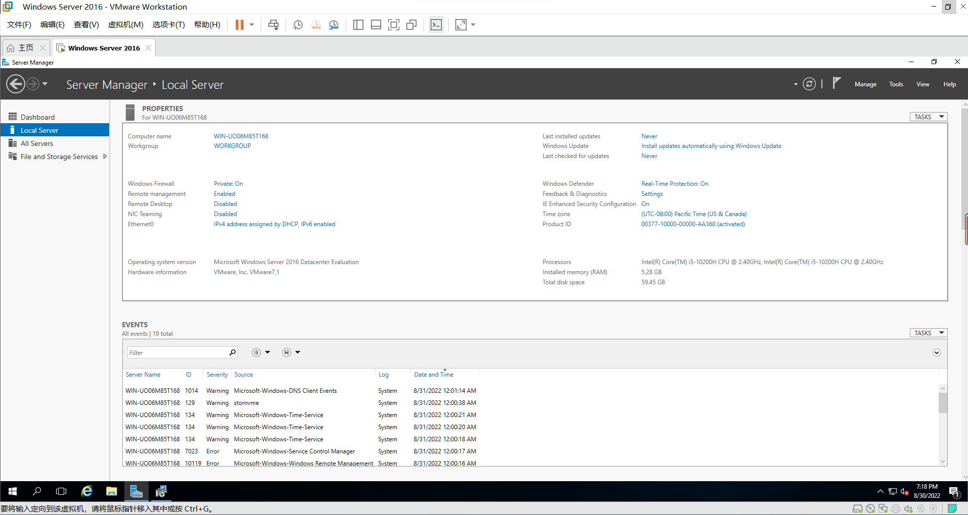

4. Leave Server Manager open.

5. Alternatively, you can determine if your computer is in a domain or workgroup from the System window. Right-click Start and click System. Look under the heading Computer name, domain, and workgroup settings.

6. Close the System window.

Activity 1-4: Testing for IP Address and Connectivity

**Objective**: Practice using the Windows Server 2016 Windows PowerShell window with the pathping and tracert commands.

**Description**: Two tools that enable you to test IP-addressing issues and connectivity on a net- work are pathping and tracert. pathping is used to test connectivity to another network by using IP address information. pathping can also calculate the number of IP packets returned from each router through which pathping passes. tracert simply determines the number of routers, called hops, through which it passes. Because both utilities report IP addressing for the hops, you can use them not only to determine connectivity but also to identify malfunctioning routers by IP address. This activity enables you to practice both commands from the Windows Server 2016 PowerShell window (or you can use Windows 7 through 10). Before you start, obtain from your instructor an off-site network address or name that you can use, or use a name from a website in the form of baidu.com.

1. In Windows Server 2016, click Start and click the Windows PowerShell tile; or click Start, click the Windows PowerShell folder, and click Windows PowerShell. In Windows 10, click Start, click the Windows PowerShell folder, and click Windows PowerShell. For Windows 8 and 8. 1, open the Apps screen and select Windows PowerShell under Windows System. In Windows 7 click Start, enter PowerShell in the Search programs and ﬁles box, and select Windows

PowerShell.

2. At the prompt, type pathping plus the name or address of the computer you are contacting, such as pathping baidu.com.

*.* *What* *results* *doyou* *see?*

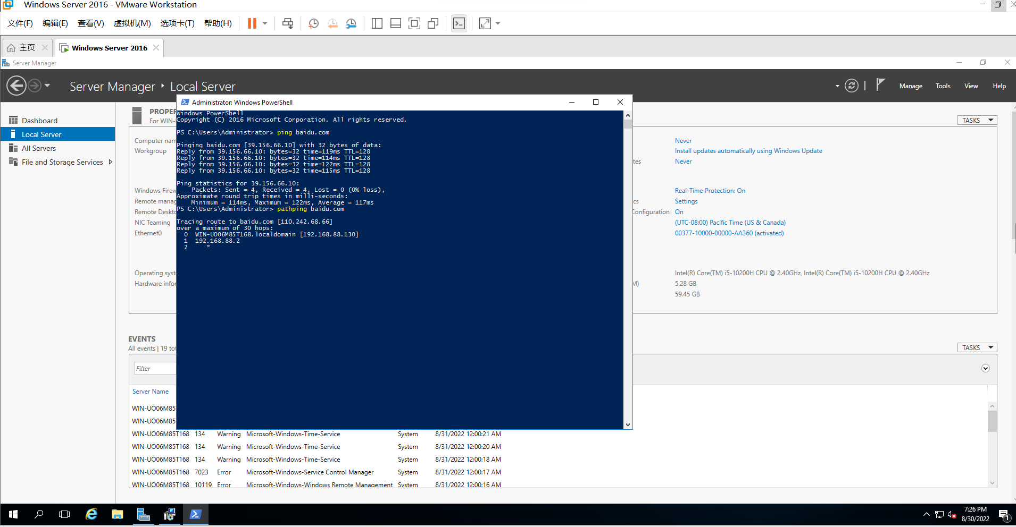

3. Next, type tracert plus the name or address of the computer you are contacting, such as tracert baidu.com.

*•* *What* *are* *the* *results?*

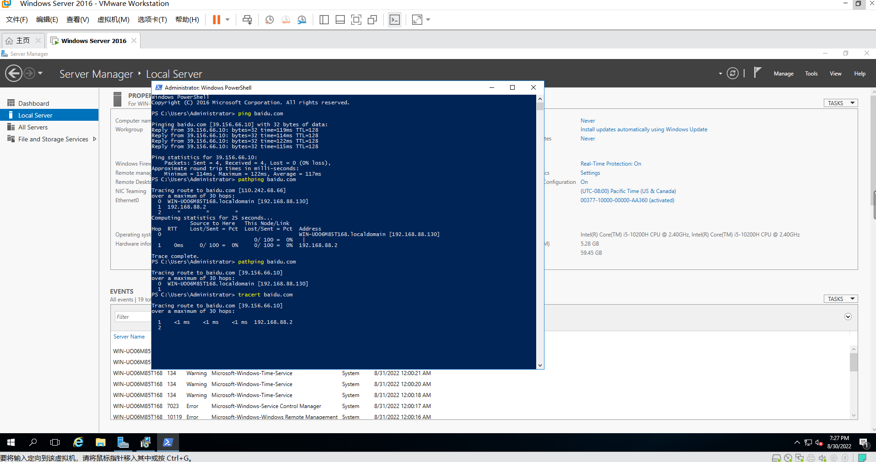

Activity 1-5: Using Sample Utilities for IP Address and Connectivity Testing

**Objective**: Practice using the Windows Server 2016 Windows PowerShell window and ARP command.

**Description**: The ARP command is a great addition to your toolkit of utilities for diagnosing a network problem. In this activity, you practice using the ARP tool with the -a option to view the contents of the ARP cache and the /? option to view a listing of all ARP options. You need to be signed in to a computer running Windows Server 2016 (or Windows 7 through10) using an account provided by your instructor or an account with administrator privileges.

1. In Windows Server 2016, click Start and click the Windows PowerShell tile; or click Start, click the Windows PowerShell folder, and click Windows PowerShell. In Windows 10, click Start, click the Windows PowerShell folder, and click Windows PowerShell. In Windows 8/8. 1, open the Apps screen and select Windows PowerShell under Windows System. In Windows 7 click Start, enter PowerShell in the Search programs and ﬁles box, and select Windows PowerShell.

2. At the prompt, type arp -a and press Enter.

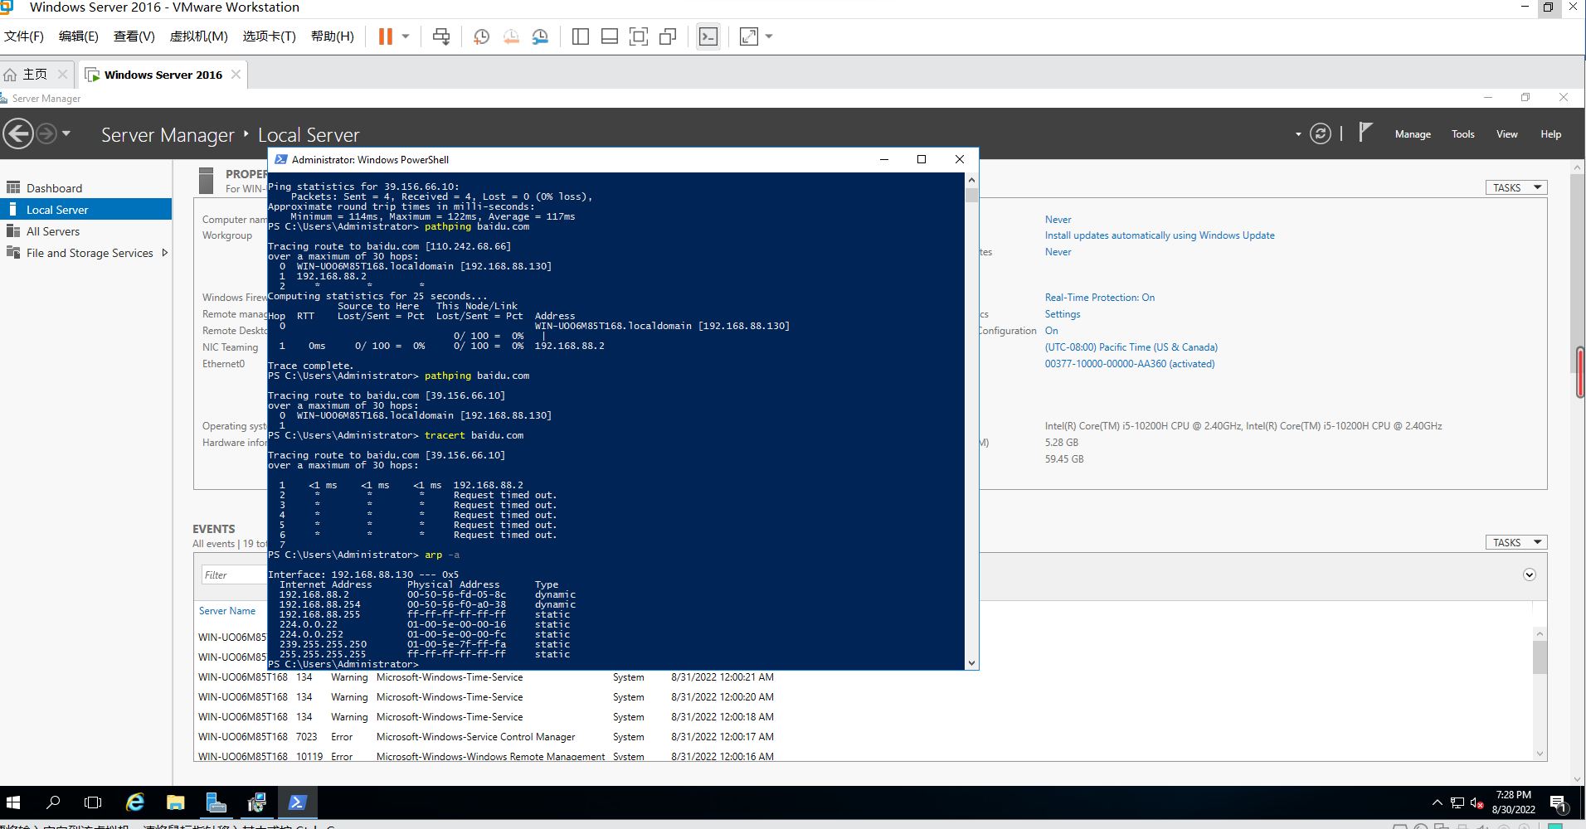

3. Type arp /? and press Enter at the prompt.

• *What* *switches* *are* *displayed* *other* *than* *-a?*

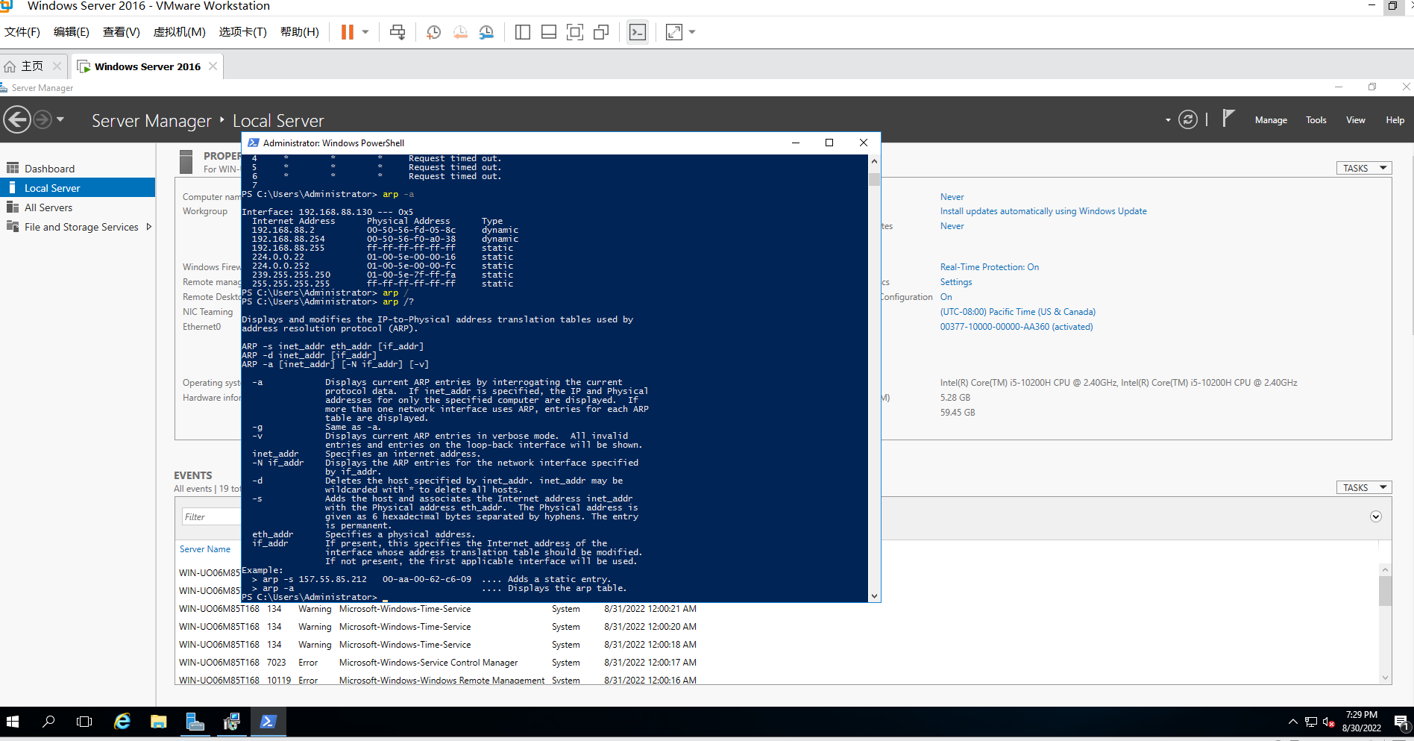

Activity 1-6: Verifying TCP/IP and the NIC Are Enabled

**Objective**: Ensure that TCP/IP and the computer’s NIC are enabled in Windows Server 2016. **Description**: If your network connection is not working, you can check to ensure that TCP/IP is enabled. It is important to know where to enable or disable TCP/IP to help troubleshoot network problems. Also, there might be times when you want to disable TCP/IP so users do not access a server while you are working on it. In addition, it is possible to disable a computer’s NIC, which additionally prevents network communications to that computer. The following steps show you where to enable or disable TCP/IP and the NIC. You will need to sign in using an account that has Administrator privileges.

1. Ensure that your computer is physically connected to a network, such as through an Ether- net cable.

2. Open Server Manager, if it is not already open.

3. If necessary, click Local Server in the left pane of Server Manager.

4. In the right pane under Properties, ﬁnd the network connection listing, such as Ethernet. Click the link to the right, such as the IPv4 address that is listed when a static address has been assigned or DHCP when it is used.

5. If necessary, click (one click only) the server’s connection, such as Ethernet, to highlight and select the connection. Near the top of the Network Connections window, if the NIC is currently enabled, you will see an option to Disable this network device. If the NIC is disabled, you’ll see an option to Enable this network device. Make sure you see the option to Disable this network device (which means it is enabled). Double-click the server’s connection, such as Ethernet.

6. In the Ethernet Status window, ensure that the Media State shows Enabled. Click the Properties button.

7. In the Ethernet Properties window, scroll through the section entitled This connection uses the following items:. Check to see if TCP/IP is enabled. If it is currently enabled, you’ll see one or both of Internet Protocol Version 6 (TCP/IPv6) and Internet Protocol Version 4 (TCP/ IPv4) with checkmarks in their boxes.

*•* *What* *canyou* *do* *to* *initiate* *conﬁguringyour* *NICfrom* *the* *currently* *open* *window?*

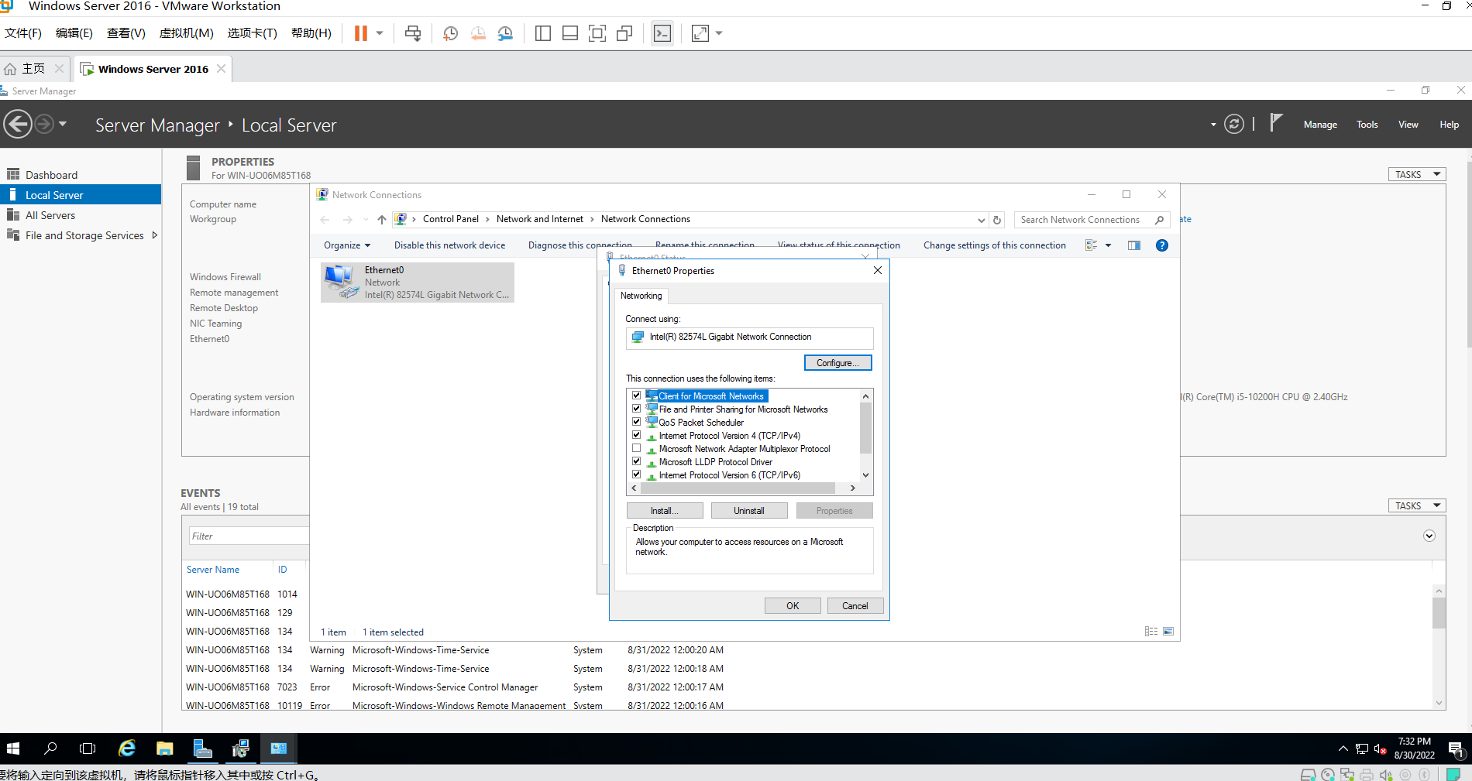

8. Leave the Ethernet Properties dialog box open for the next activity (unless you can’t complete the next activity at this time).

Activity 1-7: Conﬁguring TCP/IP for Static Addressing

**Objective**: Learn how to manually conﬁgure TCP/IP for situations in which static address- ing is used.

**Description**: Some organizations prefer to use a static IP address for some or all of the comput- ers on the network. For example, servers are often given a static IP address that does not change, because if it did, there might be confusion about how to reliably access a particular server. In this activity, you learn how to conﬁgure the TCP/IP address information manually. Before you start, obtain an IP address, subnet mask, and default gateway from your instructor. Furthermore, obtain an IP address for the preferred DNS server, and if needed, an address for the alternate DNS server. For this activity, assume you are conﬁguring IPv4. Also, you will need to sign in using an account that has Administrator privileges.

1. Make sure that the connection Properties dialog box, such as Ethernet Properties, is still open from the previous activity. If it is not, review Steps 1– 7 in Activity 1-6.

2. Double-click Internet Protocol Version 4 (TCP/IPv4).

3. Click Use the following IP address, and then type the IP address, Subnet mask, and Default gateway provided by your instructor for this computer. (If necessary, enter periods after each number set in the IP address to advance from box to box.)

4. If necessary, click Use the following DNS server addresses.

5. Type the IP address for the Preferred DNS server and, if needed, type the IP address for the Alternate DNS server.

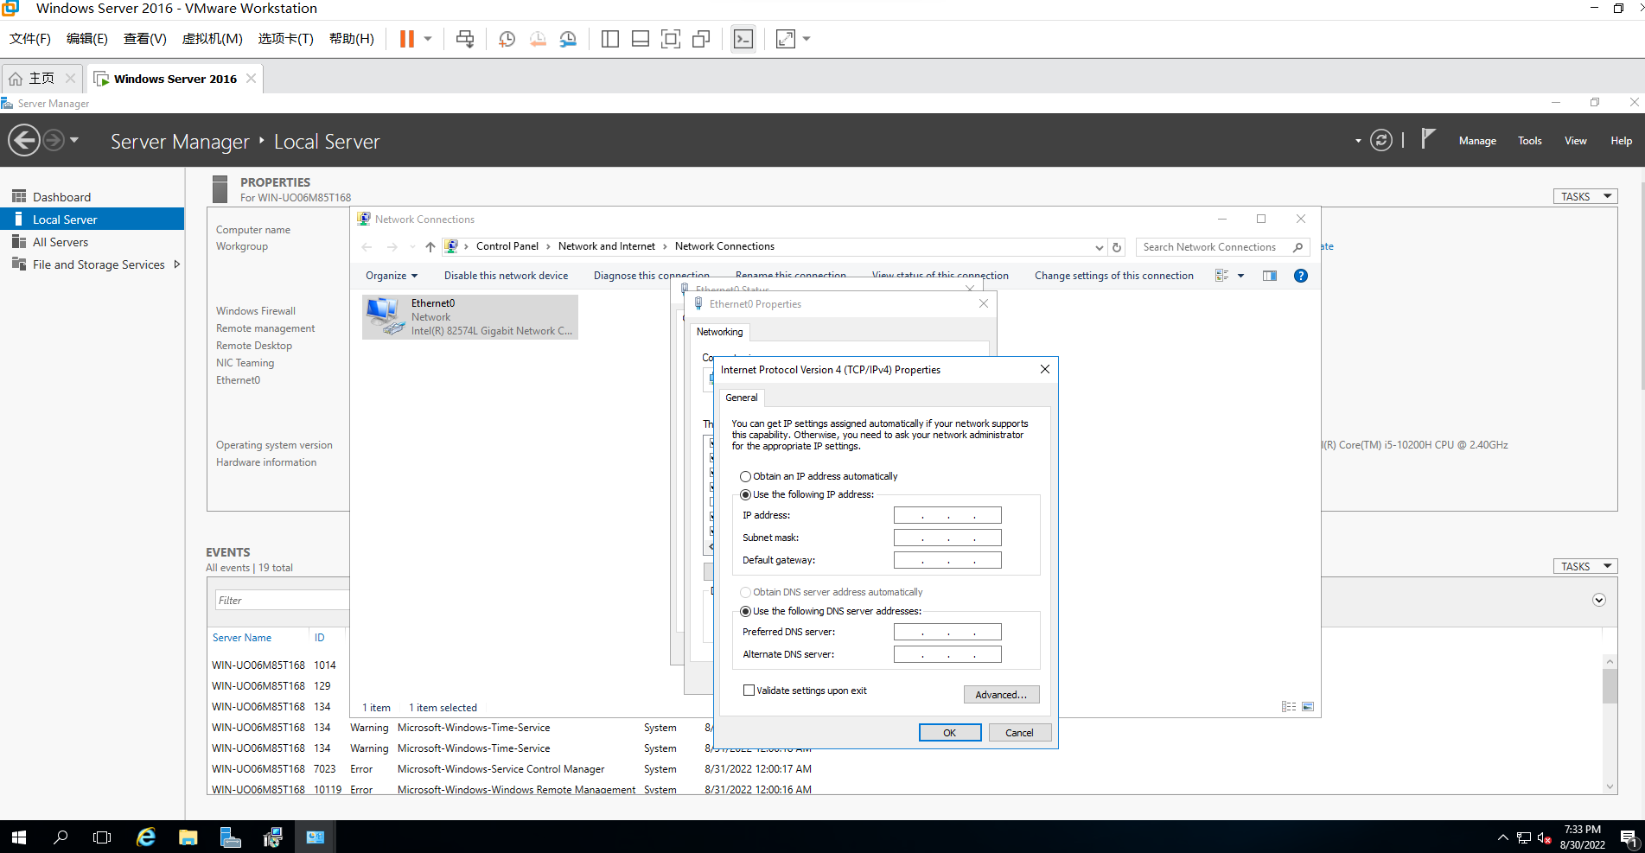

6. Click the Advanced button.

*•* *What* *tabs* *are* *availablefor* *advanced* *information?*

7. Click each tab to see the speciﬁc information that you can enter. Click Cancel.

8. Click OK.

*•* *What* *wouldyou* *click* *to* *start* *conﬁguring* *IPv6?*

9. Click OK in the Ethernet Properties dialog box. Close the Ethernet Status dialog box and the Network Connections window.

10. Close Server Manager.